# Purpose

The described system, unformal named BumpsFlask, is a GUI for running bumps, curve fitting and uncertainty estimation, on HPC (High Performance Computer).

# Current Implementation

The current implementation was developed as a proof of concept. That is, most of the building blocks have been implemented.

## Technology

### User Interface

The user interface is based on Flask and Flask Forms - python based web development framework. Flask itself uses Jinja - a template engine for python. It also uses Flask-JWT (Jason WebToken) for authentication.

### Database

Redis serves as the database backend. This is a key-value database, that doesn't use SQL.

Each value is stored with a unique key. If that key is already exists, the value is overwritten.

Slurm was selected as workload management and distribution. However, it is not yet implemented.

Bumps, BumpsFlask (the user interface) and Redis, run on Ubuntu, Linux based operating system. Bumps and BumpsFlask runs on one Docker container, while Redis runs on another Docker container.

## Source & Directories

The system source files are in

bumps / extra / bumps_flask

They can be found online at Raul's github repository: https://github.com/rnegron/bumps

## Running Bumps

Bumps runs in the folowing steps.

1. Connecting - getting a token
2. Defining the problem in a pyhon file.
3. Setting up job details
4. Submitting the job
5. Displaying results

|  |  |  |
| --- | --- | --- |
|  | click  Request |  |
|  | click Back |  |
|  | click Go |  |
| C:\Users\one4\AppData\Local\Microsoft\Windows\INetCache\Content.Word\P.PNG | Fill the necessary fields, click Submit Job.  Refresh the browser until results are displayed |  |

## Defining the problem

The following is an example[1] for curve fitting problem in python

from bumps.names import *

x = [1, 2, 3, 4, 5, 6]

y = [2.1, 4.0, 6.3, 8.03, 9.6, 11.9]

dy = [0.05, 0.05, 0.2, 0.05, 0.2, 0.2]

def line(x, m, b=0):

return m * x + b

M = Curve(line, x, y, dy, m=2, b=2)

M.m.range(0, 4)

M.b.range(-5, 5)

problem = FitProblem(M)

# Under the hood

## Background

### Flask

Flask, which is the basis for *BumpsFlask*, operates so that the UI is in html files, while processing is done in python. Clicking on a link or a button, on an html file, usually invokes a python function. That function performs its tasks and returns control, or *redirects*, to an html file

### Tokens

Tokens are created by the server andsaved by the client. When a user requests access to a resource server (e.g. BumpsFlask), the token is used to authenticate the server.

BumpsFlask uses two tokens types: access and refresh. Access tokens are needed to access the data itself. Refresh tokens are needed, along with used id, to generate new access token.

The idea is that if an Access token is compromised, the bad guys have little time to cause damage.

Refresh tokens, on the other hand, are long lived. If compromised, it can not be used to generate access token without the user id.

Good source about protocols and security can be found here:  
<https://iam.harvard.edu/resources/behind-login-screen>

Source for refresh token:  
<https://auth0.com/blog/refresh-tokens-what-are-they-and-when-to-use-them/>

Discussion about the need for both refresh and access tokens:  
<https://stackoverflow.com/questions/3487991/why-does-oauth-v2-have-both-access-and-refresh-tokens>

## Connecting - Getting the Token

When starting the BumpsFlask, at http://localhost:5000, flask invokes index() function in views.py. The current token is retrieved from get_jwt_identity() to jwt_id (Json Web Token). The index.html file is displayed. This file accept an access token, in a variable called jwt_id. If the token exists, dashboard.html is displayed with the user token, as shown in .

Otherwise, i.e. jwt_id = NULL, the page on Figure 2 is displayed, suggesting the user to request a token.

|  |  |
| --- | --- |
|  |  |
| Figure : Login page with token | Figure : Login page withput token |

The HTML forms in Figure 2 is created in the function index() (in views.py), by instantiating a TokenForm object. That form is passed to index.html as an argument, named form.

Clicking the Request button invokes tokenizer function (views.py)[2]. First, a unique user ID is generated by calling a function from the uuid family (in user_token, in api.py). That ID is used to create both access and refresh tokens, in register_token (api.py), where they are saved to Redis database. Note that the refresh token is save to Redis in register_token, while the access token is saved to Redis in create_auth_token (api.py), itself called from register_token. The tokens are also encoded and saved to cookies in index (views.py)[3].

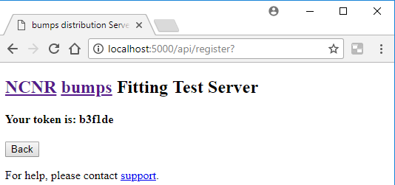

Figure : tokenizer with token

If a token does exist, tokenizer.html is displayed, with the user ID (user_token variable) passed as argument for display (b3flde in the example).

When the user selects Back, index function is called. This time the token does exists, and the control is redirected to dashboard function, by calling:

return redirect(url_for('dashboard'))



Figure : Acquiring a token

## Jobs Results

BumpsFlask operates in jobs. A job is the framework of submiting, processing, storing and displaying the results. A user access token is required before submitting a job. That token is used later as an access key to the results.

### User Interface

Once the user obtains an access token through request, tokenizer.html is displayed. That page both enables submitting a new job, and displays current results associated with the current user (token, actually). The mechanism of results display is discussed later.

### How is works

After obtaining a token (described in Connecting - Getting the Token, pg. 4), index function (view.py) is called that redirects to dashboard function (view.py).

Called from tokenizer (views.py), with the user token as argument, as shown in . Clicking Back invokes the index function (in views.py). That function reads the user ID from the cookie[4], by calling get_jwt_identity[5]. Since this time a user ID exists, control is redirected to dashboard function (views.py).

The dashboard function:

* Retrieves the current user ID from the cookie.
* Use the ID to retrieve the jobs from Resid database.

Note: Redis stores data as key-value pairs. In our case, the stored data is a python tuple, and the key is the current ID. Examples for such a tuple is displayed in Table 1.

| Table : Example for job tuple saved in Redis database | |
| --- | --- |
| key | data |
| origin: | 172.17.0.1, |
| status: | COMPLETED |
| filebase: | curv_fit |
| completed: | Mon Feb 26 13:59:59 2018 |
| submitted: | Mon Feb 26 13:59:53 2018 |
| user: | 3451a0 |
| directory: | /tmp/bumps_flask/fit_problems/3451a0/job1 |
| _id: | 1 |

* Loops over all the jobs. For each job, the results files names are saved in a set, called files. The files themselves are zipped, to a file called job_results.zip. That zip file is stored in the following directory:

/tmp/bumps_flask/fit_problems/*user_ID*/job1/results/

* Finally, control is passed to dashboad.html, with the user ID, jobs, and files names are passed as arguments.

At the end of dashboard.html, a small HTML form enables the user to submit a new job, by linking an HTML button to fit_job python function (views.py).

## Results Display

Since all bumps results are stored in files, .

### User Interface

Results are displayed in dashboard.html.

All the jobs' results are displayed in a single page.

Graphic results, such as PNG files, are display as HTML image inputs, e.g. <input type="image" src="file_name">.

Other results are displayed with the file name and a "download button, as shown in Figure 5.

Downloading

Each file A button enables downloading all the zipped results. Clicking the download button opens a "Save As" dialog box, that lets the user choose the result file name, and if selected, download the zipped file.

Deleting

Another button enables deleting the jobs results. Clicking that button deletes both the job from the Redis database and the files from the results directory.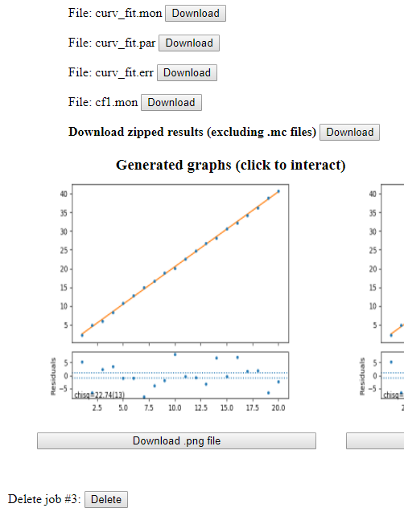

Figure : Display example for alphanumeric results

Go button redirects to a new job entry form.

Logout button deletes the current user ID and redirects to the login page (Figure 2, page 5).

How it works

After loading the user ID, jobs, and results files in dashboard function, it is redirected to dashboard.html page.

The page loops over all the jobs, and display all the results files for that job. Each file name is display n a different line. After the file name, a button with a download caption is displayed.

Each compination of a file name and the button are an HTML form. The form's action is the file name. The browser's respond to such a file type is to download it. Therefore, no additional code is required.

file name and the button are

a pitFor every job, the page displays the charts produced (png file), and enebles downloading files that are not displayed.

Also, each

How it works

The display is based on user ID, job data, and results files thata ere retrieved in dashboard function (views.py)

## Submitting a Job

The dashboard function displays current user results, and lets the user the submit another job, in the pages shown in Figure 7. That part of the dashboard html page, is a form with a submit button, that is redirected on click to fit_job (views.py).

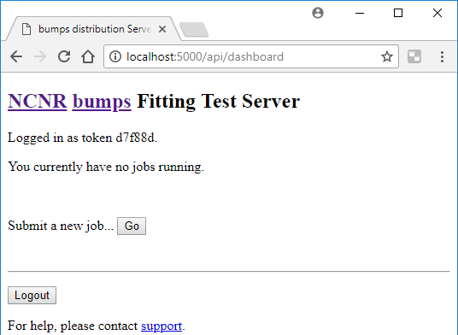

Figure : dashboard without results

as well as the user ID is retrieved from a cookie, again by calling get_jwt_identity. This ID it used as the key to extract all the jobs stored in the Redis database. dashboard then calls update_user_jobs, which, well, updates the jobs status.

Uppon creation, a job status is set to PENDING. When the job starts to run, the status is changed to Running, and a JSON file is created. That file is an indication that the

|  |  |  |
| --- | --- | --- |
| Table : Job Status f(files existance) | | |
| JSON  Exists | HTML  Exists | Job Status |
| No | No | PENDING |
| Yes | No | RUNNING |
| No | Yes | ? |
| YES | Yes | Completed |

it's status is changed to RUNNING, and. That file signals The status is determined by exsitance of files: if a JSON fiole exsits, that means that the algorithm

Results display is described later in the chapter.

Whether there is data or not, dashboard.html displays the a Go button, enabling the user to submit a new job,

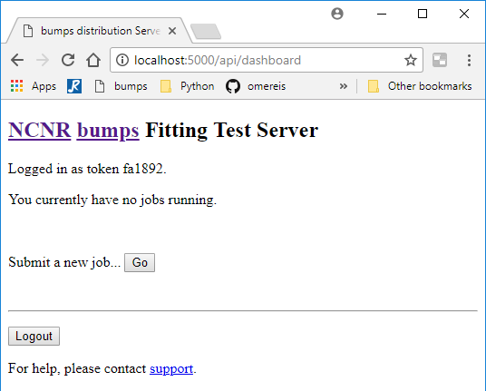

Figure : Dashboard without results

, the dashboard page is displayed, presenting current jobs associated with the current token.

Display Without Results

This part of dashboard.html is displayer

Results Display

If no results are available for the current token

When the user clicks Request, it invokes the function tokenizer (views.py), which generates a token through uuid, and returns a redirect

Within the python backend, first the [user access] token is retrieved. If a token exists, the user is redirected to dashboard. Otherwise, it redirects to index.

The python backend is implemented by the index function, in views.py.

If the user has a token, The first part displays messages, relating to the user token/login status.

This page displays a message stating weather the user is logged in or not. If not, the

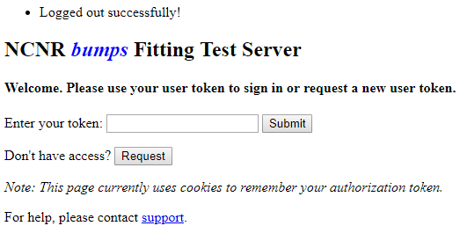

Building the application

Running the

The user interace, implemented on top of Flask/FlaskForms, generate bumps command line. That command is being submitted to slurm. Slurm, then, runs the application on the allocated nodes.

The GUI runs slurm as a command line. The results are saved in a temporary directory. The GUI loads the files for display from the temporary directory.

User ID and permission, and job details, are save in a Redis database.

Further development

understand slurm. make it work with docker containers.

let the user know when the running is over, without the need to refresh the screen. chack possibility of sending email/sms

Note: The current implementation, bumps and Redis are running on different containers. They interact using the docker run's --link option. However, according to Docker, this option should not be used, and maybe ommited in the future.

https://docs.docker.com/network/links/

According

At least this was the plan.

At this point in time, slurm is not installed on the docker machine.



slurm file parameters and a

This is done through web interface



The prupose of the system is to build a (relativly) simple GUI that will let users run bumps on a

The bumps application runs from a unix command line, with parameters defining the problem to be solved and the desired environment. Such parameters include, for example, the optimization algorithm, problem data and so on.

Notes

|  |  |  |
| --- | --- | --- |
| Topic | Description | Solutions |
| Tokens | Refresh token not used |  |
| Slurm | Slurm script is written but not implemented. |  |
| Redis --link | Redis runs an a different container (good thing), and linked to bumps through --link.  That option is about to be deprecated. |  |
|  |  |  |
| Software Enginering | The code is hard to change, since the calls to external procedures, e.g. the database, are part of the code. It would be much more flexible if all database eferences would be stored in seperate class(es), which will encapsulate all physical database access. |  |
| Inputs | Building forms with Flask Form, WTForms, makes it harder to develope a friendly application. |  |
| Resuls | bumps stores results in files. While image files are shown, data files are not. |  |
| Results | Users have no tools for browsing among existing results. |  |
| Results | Missinga housekeeping tool for results files. |  |
| Users | Survey users to get their expectations and needs. |  |
| Result | Display alphanumeric data files |  |
| bug | Run a job, then another two with the same token.  Delete one job, and add another job.  There are 3 jobs in the Redis database, but only 2 sets on the results file. This is because of the way results directories are named. |  |
| bug | Killing the bumps container removes all the results files. However, Redis database does not change.  The result is that one can log in with a token that is valid for Redis, but with all the results files lost. |  |

Bumps user interface employs

היישום מופעל

stack רץ רק על swarm

Slurm

האפליקציה של ראול

הפעלה של יישום האופטימיזציה bumps באמצעות docker. ממשק המשתמשים web באמצעות flask/jinja.

היישום רץ על קונטיינר של docker שמפעיל מערכת unix/ubuntu.

היישום מפעיל flask עם מערכת forms בשם flask_wft לצורך איסוף נתוני משתמש.

הנתונים כוללים את הבעיה המוגדרת ב-bumps, מספר מעבדים, שיטת פתרון וכדומה.

לאחר איסוף הנתונים ווידוא תקינות, הם מועברים ל-slurm שפועל על הקונטיינר באמצעות command line.

עוד לא ברור לי איך ה-slurm צעביר את ה-job למעבדים. כנראה שאין חלוקת ה-jobs לקונטיינרים של docker.

השימוש ב-redis הוא לצורך זיהוי משתמש (כעת רק וירטואלי) ושמירת פרטי ה-job שנשלח ל-slurm.

המטלה כעת

לחבר את ה-slurm לענן פיסי.

לבדוק אפשרות ניצול MPI

לבדוק ממשק windows ל-slurm, או שימוש ב-scheduler אחר.

תאור היישום

היישום העיקרי נקרא bumps. ביישום מופעלים אלגוריתמים לקרוב אופטימלי.

היישום פועל בסביבת יוניקס.

הממשק שנבנה מפעיל סביבת Linux בתוך docker container.

יישום זה משתמש במספר תוכנות וסביבות עבודה:

slurm - מערכת open source לתיזמון עבודות וניהול משאבים.

redis - מסד נתונים לא sql-י ששומר ערך מול מפתח. redis משמש גם לזיהוי משתמשים על ידי שמירת toekn, וגם לשמירת הפרמטרים לצורך העברת job ל-slurm.

flask - סביבת עבודה מבוססת python לפיתוח יישומי web.

flask forms - תוספת ל-flask שמקלה על העברת נתונים מה-web ליישום ב-python.

אופן הפעולה

cnal vrtah היישום מקבל פרטי הפעלה מהמשתמש באמצעות ממשק web: מספר מעבדים, זיכרון, שם ה-job, אלגוריתם, הגדרת הבעיה (בקובץ python) וכדומה. הפרטים האלו מועברים ל-Slurm, ששולח אותם לעיבוד, ומחזיר תשובה ליישום, שמציג את התשובה על המסך.

העברת הנתונים ל-Slurm מבוצעת על ידי שמירתפ בקובץ, והפעלת slurm עם פקודת command line.

בשלב זה לא ברור לי איך מתקבלת התשובה, ובמה נעזר ראול כדי להציג גרפים.

כניסה לאתר מותנית ב-token. המשתמש מבקש token, מקבל מספר אקראי, וממשיך למסך קליטת הנתונים. המטרה הייתה ככל הנראה להתנות כניסת משתמשים בזיהוי.

ה-container של docker הוא סביבת Linux.

הממשק ל-container הוא באמצעות port 5000



בעיה נוכחית: איך להכניס שינויים בקוד ולהריץ במינימום זמן.

צריך לזכור שהשינויים יכולים להיות לא רק בחבילה העקרית - bumps_flask - אלא גם בכל הקבצים שממשים את ממשק עם slurm.

1. From Negron and Keinzle, A web-based service for distributing curve fitting algorithms onto remote server clusters for improved performance, p. 8
2. The link between the button and the python function is stored in the htm file.
3. By calling set_access_cookies() and set()refresh_cookies()
4. Note that the user ID is stored in a variable called user_token, which is somewhat confusing.
5. Which reads the user ID from a cookie